Joel Edwards
Course: Java Programming 1
Homework 3
April 9, 2011

1)

Source:

ParseEval.java:
import java.util.ArrayList;
import java.util.StringTokenizer;

class ParseEval
{
public static final int NONE = 0;
public static final int ADD = 1;
public static final int SUBTRACT = 2;

private static void error(String message) {
System.out.println("E: " + message);
System.exit(1);
}

public static void main(String[] args) {
StringTokenizer tokenizer;
ArrayList<String> tokens = new ArrayList<String>(args.length);

// Look for tokens within each token returned from the command-line
for (String arg: args) {
tokenizer = new StringTokenizer(arg, "-+", true);
while (tokenizer.hasMoreTokens()) {
tokens.add(tokenizer.nextToken());
}
}

boolean last_was_value = false;
int last_delimiter = ADD;
double value = 0;
double total = 0;
int token_index = 1;
for (String token: tokens) {
if ("+".compareTo(token) == 0) {
if (!last_was_value) {
error("Adjacent operators are not allowed");
}
last_delimiter = ADD;
last_was_value = false;
} else if ("-".compareTo(token) == 0) {
if (!last_was_value) {
error("Adjacent operators are not allowed");
}
last_delimiter = SUBTRACT;
last_was_value = false;
} else {
try {
value = Double.parseDouble(token);
if (last_was_value) {
error("Adjacent values are not allowed");
}
last_was_value = true;
if (last_delimiter == SUBTRACT) {
total -= value;
} else if (last_delimiter == ADD) {
total += value;
} else {
// This should never occur
error("Unsupported arithmetic operation");
}
} catch (NumberFormatException e) {
error("Unsupported input value '" +token+ "'");
}
}
token_index++;
}

System.out.println("" + total);
}
}

Output:
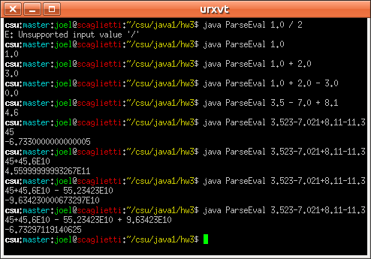

2)

Source:

DrawT.html:
<html>
<head>
<title>A Simple Program</title>
<meta http-equiv="pragma" content="no-cache" />
</head>
<body>
Here is the output of my program:
<applet code="DrawTApplet.class" width="300" height="400">
</applet>
</body>
</html>

DrawTApplet.java:
import java.applet.Applet;
import java.awt.Color;
import java.awt.Graphics;

public class DrawTApplet
extends Applet
{
private static final int NEG = -1;
private static final int POS = 1;

private Graphics g = null;

public void paint(Graphics g) {
this.g = g;
this.resize(300, 400);
this.setBackground(Color.white);

// Draw line segments
this.drawPyramid(Color.RED, 1, 50, POS, 50, POS, 249, NEG, 50, POS);
this.drawPyramid(Color.GREEN, 1, 249, NEG, 50, POS, 249, NEG, 99, NEG);
this.drawPyramid(Color.ORANGE, 1, 249, NEG, 99, NEG, 174, NEG, 99, NEG);
this.drawPyramid(Color.BLUE, 1, 174, NEG, 99, NEG, 174, NEG, 349, NEG);
this.drawPyramid(Color.YELLOW, 1, 174, NEG, 349, NEG, 125, POS, 349, NEG);
this.drawPyramid(Color.MAGENTA, 1, 125, POS, 349, NEG, 125, POS, 99, NEG);
this.drawPyramid(Color.DARK_GRAY, 1, 125, POS, 99, NEG, 50, POS, 99, NEG);
this.drawPyramid(Color.PINK, 1, 50, POS, 99, NEG, 50, POS, 50, POS);
}

public void drawLine(Color c, int x1, int y1, int x2, int y2) {
this.g.setColor(c);
this.g.drawLine(x1, y1, x2, y2);
}

public void drawPyramid(Color c, int depth,
int x1, int dx1,
int y1, int dy1,
int x2, int dx2,
int y2, int dy2) {
for (int i = 0; i < depth; i++) {
this.drawLine(c,
x1 + (dx1 * i),
y1 + (dy1 * i),
x2 + (dx2 * i),
y2 + (dy2 * i));
}
}
}

Output:

Single pixel lines were a little too thin, so I created the drawPyramid method in order to draw the T with line thickness determined by the depth parameter. The results were pretty interesting for a depth of 25 (second screenshot).

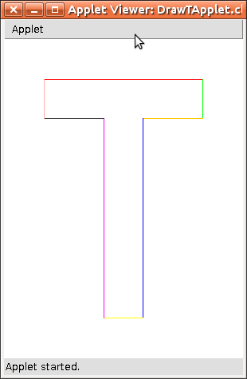
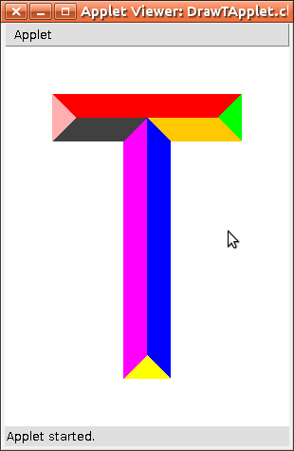

3)
String's split method(s) can quickly breaking up a String into an array of tokens based on more complex delimiters than those allowed by StringTokenizer.

4)
Graphics' clearRect method is useful for clearing portions of the Graphics' canvas, or the entire canvas.

5)

Source:

DrawTResize.html:
<html>
<head>
<title>A Simple Program</title>
<meta http-equiv="pragma" content="no-cache" />
</head>
<body>
Here is the output of my program:
<applet code="DrawTResizeApplet.class" width="300" height="400">
</applet>
</body>
</html>

DrawTResizeApplet.java:
import java.applet.Applet;
import java.awt.Color;
import java.awt.Container;
import java.awt.event.ComponentListener;
import java.awt.event.ComponentEvent;
import java.awt.Graphics;

public class DrawTResizeApplet
extends Applet
{
private Graphics g = null;
private int w_div = 6; // Divide width by this value to determine width of stemp of the T
private int h_div = 8; // Divide height by this value to determine height of cross of the T

public void paint(Graphics g) {
this.g = g;

this.setBackground(Color.WHITE);
this.g.setColor(Color.BLACK);

// Here we handle the re-sizing of the Applet, and ignore all other
// events returned by the ComponentListener
this.addComponentListener( new ComponentListener() {
public void componentHidden(ComponentEvent e) { ; }
public void componentMoved(ComponentEvent e) { ; }
public void componentResized(ComponentEvent e) {
DrawTResizeApplet a = (DrawTResizeApplet)e.getComponent();
a.redrawT();
}
public void componentShown(ComponentEvent e) { ; }
});

this.redrawT(); // Draw the initial T prior to any resize events
}

public void redrawT() {
int width = this.getWidth();
int height = this.getHeight();

// We use these ratios to determine whether the T's dimension should
// be calculated with respect to width or height.
double targetRatio = (float)(this.w_div) / (float)(this.h_div);
double dimRatio = (float)(width) / (float)(height);

int top_x; // x-coordinate of upper left corner of the T's cross
int top_y; // y-coordinate of upper left corner of the T's cross
int top_w; // width of T's cross
int top_h; // height (thickness) of T's cross
int cnt_x; // x-coordinate of the upper left corner of the T's stem
int cnt_y; // y-coordinate of the upper left corner of the T's stem
int cnt_w; // width (thickness) of the T's stem
int cnt_h; // height of the T's stem

// Calculate dimensions with respect to height
if (dimRatio > targetRatio) {
top_y = height / h_div;
top_y = (top_y < 1) ? 1 : top_y;
top_h = top_y;
top_h = (top_h < 1) ? 1 : top_h;
cnt_y = top_y;
cnt_y = (cnt_y < 1) ? 1 : cnt_y;
cnt_h = height - ((top_y) * 2);
cnt_h = (cnt_h < 1) ? 1 : cnt_h;

cnt_w = top_h;
cnt_w = (cnt_w < 1) ? 1 : cnt_w;
cnt_x = width / 2 - (cnt_w / 2);
cnt_x = (cnt_x < 1) ? 1 : cnt_x;
top_w = cnt_h * w_div / h_div;
top_w = (top_w < 1) ? 1 : top_w;
top_x = width / 2 - (top_w / 2);
top_x = (top_x < 1) ? 1 : top_x;
}
// Calculate dimensions with respect to width
else {
top_x = width / w_div;
top_x = (top_x < 1) ? 1 : top_x;
top_w = width - ((top_x) * 2);
top_w = (top_w < 1) ? 1 : top_w;
cnt_x = (width / 2) - ((top_x) / 2);
cnt_x = (cnt_x < 1) ? 1 : cnt_x;
cnt_w = top_x;
cnt_w = (cnt_w < 1) ? 1 : cnt_w;

cnt_h = top_w * h_div / w_div;
cnt_h = (cnt_h < 1) ? 1 : cnt_h;
cnt_y = height / 2 - (cnt_h / 2);
cnt_y = (cnt_y < 1) ? 1 : cnt_y;
top_h = cnt_w;
top_h = (top_h < 1) ? 1 : top_h;
top_y = cnt_y;
top_y = (top_y < 1) ? 1 : top_y;
}

this.g.clearRect(0, 0, width, height); // Remove previous T image
this.g.fillRect(top_x, top_y, top_w, top_h); // Draw T's cross
this.g.fillRect(cnt_x, cnt_y, cnt_w, cnt_h); // Draw T's stem
}
}

Output:
